Product Rationale: This product will be an app to search for books from the bookstoscrape website and it is useful to search for books in various categories and for specific books. Implementation Details: 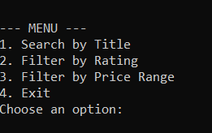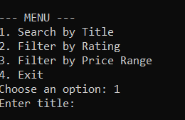 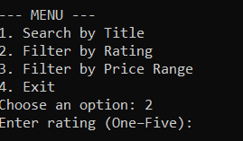 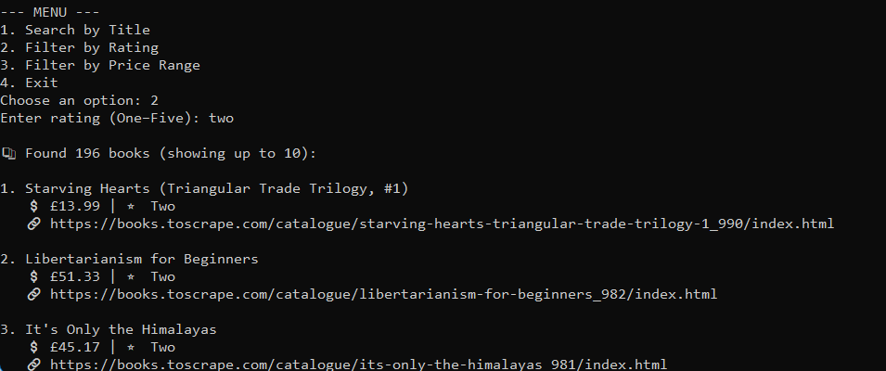  (Not finished yet)
User Documentation: The user will follow the menu’s instruction (see pictures) and type a corresponding number then it will pull up another page (see pictures) depending on which number you pick and it will have more instruction (see pictures) to follow and that is all you do.

